CSA09 – PROGRAMMING IN JAVA

ASSIGNMENT 4 – CO4

EVENT-DRIVEN GUI DESIGN
Name: V C BHAVAN BAIRAV
Register Number: 192511369
Department: Computer Science and Engineering
Academic Year: 2026–2027

1. INTRODUCTION
This assignment focuses on the design and implementation of event-driven graphical user interfaces using Java AWT and Swing. It covers event handling, listener interfaces, adapter classes, inner classes, anonymous classes, lambda expressions, layout managers and database connectivity.
The assignment consists of six tasks involving GUI design, event handling, debugging, application development and performance comparisons.
The main objective is to understand how Java applications respond to user interactions and how different event-handling techniques can be implemented.

2. TASK 1 – GUI DESIGN REVIEW: FEE PAYMENT

2.1 Problem Analysis and Diagnosis
The original FeeWindow implementation contains several design and programming issues that affect its functionality, responsiveness and maintainability.
S.No. | Identified issue | Explanation
1 | Mixed responsibilities | GUI and payment logic are implemented together.
2 | String comparison | Using == to compare action commands can produce incorrect results.
3 | Missing validation | Invalid or empty input can cause runtime exceptions.
4 | Database operation on EDT | Database operations can make the interface unresponsive.
5 | Thread.sleep() | Blocks the event-dispatch thread.
6 | Missing receipt handler | Receipt functionality is not implemented separately.
7 | SQL concatenation | Directly combining user input with SQL creates security risks.
8 | Resource management | Database connections and statements are not properly closed.
9 | Exception handling | Database-related exceptions are not handled appropriately.
10 | Limited feedback | Results are displayed through console output instead of GUI messages.

2.2 Proposed Class Structure
The implementation separates the GUI from the payment-processing logic using two classes.
Class Diagram

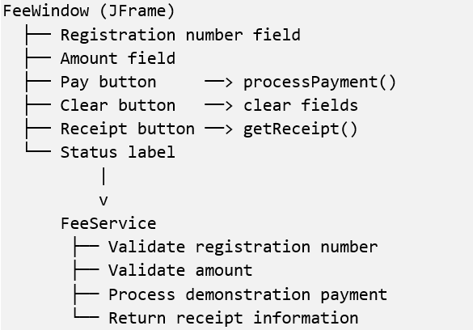

2.3 Class Responsibilities
Class | Responsibility
FeeWindow | Collects user input, handles button events and displays results.
FeeService | Validates registration details, processes payment and generates receipt information.
The Pay button invokes the payment-processing method. The Clear button removes the entered values, while the Receipt button retrieves and displays receipt information.

2.4 Working Procedure
- The user enters the registration number.
- The user enters the payment amount.
- The Pay button triggers the payment event.
- FeeWindow passes the entered information to FeeService.
- FeeService validates the input.
- The payment operation is processed.
- The result is displayed in the GUI.
- The Receipt button displays the payment receipt.

2.5 Comparison of Event-Handling Approaches
Approach | Time complexity | Space complexity
Single listener with if-else | O(k) worst case | O(1)
Separate listener for each button | O(1) dispatch selection | O(k)
Here, k represents the number of buttons.
Using separate listeners provides direct event handling, whereas a single listener requires checking the action command before executing the corresponding operation.

3. TASK 2 – HOSPITAL OUTPATIENT APPOINTMENT DESK

3.1 Event Model
The appointment desk application uses event listeners to respond to user interactions.
Event Source | Event Object | Listener Interface | Function
Department ComboBox | ActionEvent | ActionListener | Updates the doctor list.
Book Button | ActionEvent | ActionListener | Validates and books an appointment.
Window Close | WindowEvent | WindowAdapter | Handles window closing.
Doctor ComboBox | ActionEvent | ActionListener | Retrieves selected doctor.
Time Slot ComboBox | ActionEvent | ActionListener | Retrieves selected time slot.

3.2 GUI Component Hierarchy

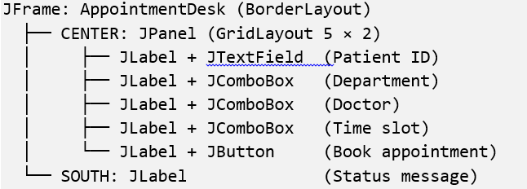

3.3 Pseudocode – Department Selection
PROCEDURE refreshDoctors

selectedDepartment ← departmentCombo.getSelectedItem()

doctorCombo.removeAllItems()

doctorList ← doctorMap.get(selectedDepartment)

FOR EACH doctor IN doctorList
doctorCombo.addItem(doctor)
END FOR

END PROCEDURE

3.4 Pseudocode – Appointment Booking
PROCEDURE bookAppointment

patient ← patientIdField.getText()

IF patient is empty OR invalid THEN
Display validation error
RETURN
END IF

IF doctor or time slot is not selected THEN
Display selection error
RETURN
END IF

bookingInProgress ← TRUE

TRY
Create appointment
Display booking confirmation

FINALLY
bookingInProgress ← FALSE
END TRY

END PROCEDURE

3.5 Event Execution Sequence
- The application starts using the main method.
- SwingUtilities.invokeLater() schedules GUI creation.
- The AppointmentDesk constructor creates the components.
- The doctor mapping is initialized.
- Event listeners are registered.
- The application window becomes visible.
- When the department is selected, an ActionEvent is generated.
- The doctor list is refreshed.
- When Book is clicked, the booking handler validates the details.
- The appointment confirmation is displayed.

3.6 Window Event Handling
The WindowAdapter class is used to handle window-closing events.
When the user attempts to close the application, the windowClosing() method is invoked. If a booking operation is in progress, a confirmation message is displayed before closing the application.

3.7 Applet Lifecycle Methods
Method | Description
init() | Initializes the applet.
start() | Starts or resumes applet execution.
paint() | Displays graphical content.
stop() | Suspends applet execution.
destroy() | Performs final cleanup.
The implemented appointment application uses JFrame and does not directly use the applet lifecycle methods.

3.8 Comparison of Doctor List Retrieval
Method | Time complexity | Memory usage
Preloaded HashMap | O(1) lookup on average, plus O(m) to populate the doctor list | O(dm)
Database retrieval | Database query time plus O(m) processing | Depends on retrieved records
Here, d represents the number of departments and m represents the number of doctors in a department.
The HashMap approach stores doctor information in memory, whereas database retrieval obtains the information whenever the department selection changes.

4. TASK 3 – CAMPUS LIBRARY SEARCH SCREEN

4.1 Layout Manager Selection
The library search application uses different layout managers to organize the GUI components.
Component | Layout Manager | Purpose
Main JFrame | BorderLayout | Divides the window into different regions.
Search Panel | FlowLayout | Arranges search controls horizontally.
Bottom Controls | FlowLayout | Arranges navigation buttons.
Bottom Container | BorderLayout | Organizes controls and status information.
Results Area | JScrollPane | Provides scrolling for search results.

4.2 Component Hierarchy Diagram
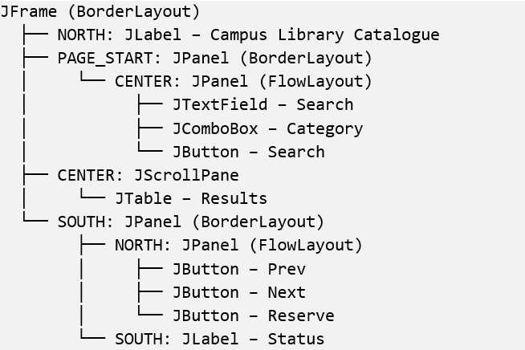

4.3 Implementation Description
The LibrarySearchScreen.java implementation creates a graphical interface for searching library resources.
The search panel contains a text field, category selection box and Search button.
The results are displayed using a JTable placed inside a JScrollPane.
The bottom section contains Prev, Next and Reserve buttons along with a status label.
The BorderLayout manager allows the central results area to expand when the window is resized, while FlowLayout arranges the controls horizontally.

4.4 Resizing Behaviour
The interface is designed to accommodate different window sizes.
Window Size | Expected Behaviour
Small | Results area occupies the available space with scrolling.
Medium | Results area expands while controls retain their preferred sizes.
Large | More results can be displayed within the expanded table area.

4.5 Comparison of Layout Managers
Layout Manager | Characteristics | Resizing Behaviour
BorderLayout | Divides the container into five regions. | Expands components according to available space.
FlowLayout | Arranges components sequentially. | Components retain preferred sizes and wrap when necessary.
GridBagLayout | Uses flexible constraints to position components. | Supports flexible component resizing.
Absolute Positioning | Uses fixed coordinates. | Requires manual adjustments during resizing.
The implementation uses nested BorderLayout and FlowLayout containers to organize the search interface.

5. TASK 4 – EVENT-HANDLING FORENSICS: DRAWING PAD

5.1 Diagnosis of the Original Code
The original drawing application contains two major issues.
Issue 1: Incorrect Method Name
The MouseAdapter class defines the callback method as:
mouseClicked(MouseEvent e)
However, the original implementation uses:
mouseclicked(MouseEvent e)
Java is case-sensitive. Therefore, the incorrectly named method does not override the original callback and is not executed when the user clicks the drawing area.
Issue 2: Direct Drawing Using getGraphics()
Drawing directly using getGraphics() does not preserve the drawing as application data.
When the window is minimized, restored or repainted, the previously drawn dots may disappear.

5.2 Corrected Implementation
The corrected implementation stores mouse-click positions in an ArrayList and redraws them whenever the component is repainted.
private final List<Point> points = new ArrayList<>();

addMouseListener(new MouseAdapter() {

@Override
public void mouseClicked(MouseEvent e) {

points.add(e.getPoint());

status.setText("Clicks: " + points.size());

repaint();
}
});

@Override
public void paint(Graphics g) {

super.paint(g);

for (Point p : points) {

g.fillOval(
p.x - 3,
p.y - 3,
6,
6
);
}
}

5.3 Working Procedure
- The user clicks anywhere inside the drawing area.
- A MouseEvent is generated.
- The mouseClicked() method is invoked.
- The clicked position is stored as a Point object.
- The click counter is updated.
- repaint() requests the component to be redrawn.
- The paint() method draws all stored points.
- Previously drawn dots remain visible after repainting.

5.4 Importance of @Override
The @Override annotation ensures that a method correctly overrides a superclass method or implements an interface method.
If the incorrectly named mouseclicked() method is annotated with @Override, the compiler reports an error because the method does not override the MouseAdapter callback.
This helps identify method-signature errors during compilation.

5.5 Comparison of Drawing Approaches
Approach | Time Complexity | Space Complexity
ArrayList of Point objects | O(n) for redrawing all points | O(n)
BufferedImage | O(width × height) for a full-image copy | O(width × height)
Here, n represents the number of stored mouse clicks.
The ArrayList approach stores individual coordinates and redraws them during repainting. The BufferedImage approach stores the rendered image and displays it when repainting occurs.

6. TASK 5 – CURRENCY CONVERTER: EVENT-HANDLING STYLES

6.1 Implementation Approaches
The currency converter is implemented using four different event-handling techniques.

1. Frame Implements ActionListener
In this approach, the main frame implements the ActionListener interface.
The actionPerformed() method handles the Convert button event and invokes the conversion operation.

2. Named Inner Class
A separate named inner class implements ActionListener.
The inner class handles the button event and accesses the enclosing frame's fields.

3. Anonymous Inner Class
An anonymous inner class is created directly while registering the event listener.
It handles the conversion operation without requiring a separate named class.

4. Lambda Expression
A lambda expression is used to implement the ActionListener functional interface.
It provides a shorter way of defining the event-handling operation.

6.2 Comparison of Event-Handling Techniques
Factor | Frame Listener | Named Inner Class | Anonymous Inner Class | Lambda
Readability | Simple for small applications | Clear structure | Compact but can become lengthy | Concise
Reusability | Limited | Good | Limited | Can be stored and reused
Code structure | Listener logic in frame | Separate named handler | Inline handler | Inline expression
Access to frame fields | Direct | Direct through enclosing instance | Direct through enclosing instance | Uses enclosing instance context
Maintenance | May increase frame coupling | Suitable for larger handlers | Suitable for small handlers | Suitable for short operations

6.3 Updated Functionality
The Convert button and amount text field are registered with the same conversion action.
The application supports the following operations:
- Enter the amount in the text field.
- Click Convert or press Enter.
- The conversion operation is executed.
- The converted amount is calculated.
- The result is displayed using a dialog box.
- If the input is invalid, an error dialog is displayed.
WindowAdapter is used to handle the window-closing operation.

6.4 Shared Action and Method Reference
A method reference such as this::convert can be used when the method signature matches the listener's functional method.
A shared Swing Action can also be registered with multiple GUI components.
Approach | Handler Objects | Reusability
Separate handler per trigger | O(k) | Separate handlers required
Shared Action | O(1) shared action object | Same action can be registered with multiple components
Here, k represents the number of event triggers.

7. TASK 6 – CAMPUS EVENT REGISTRATION DESKTOP APPLICATION

7.1 System Overview
The Campus Event Registration application is a Java Swing-based desktop application integrated with MySQL using JDBC.
It provides a graphical interface for students to register for campus events and allows committee members to view, filter and export registration information.
The application follows a layered architecture consisting of the presentation layer, service layer and data-access layer.

7.2 Main Features
Feature | Description
Student Registration | Allows students to register for campus events.
Input Validation | Validates student ID, name, event and email.
Duplicate Prevention | Prevents the same student from registering for the same event more than once.
Database Connectivity | Uses JDBC to communicate with MySQL.
Event Filtering | Displays registrations based on the selected event.
Pagination | Retrieves registration records page by page.
CSV Export | Exports the currently displayed page.
Error Handling | Displays validation and database error messages.

7.3 System Architecture Diagram
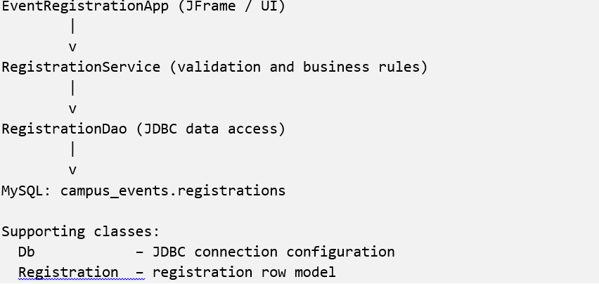

7.4 Class Responsibilities
Class | Responsibility
EventRegistrationApp | Creates the Swing interface, handles events and displays registration records.
RegistrationService | Performs input validation and handles business rules.
RegistrationDao | Executes database operations using JDBC.
Db | Establishes MySQL database connections.
Registration | Represents an individual registration record.

7.5 Registration Workflow

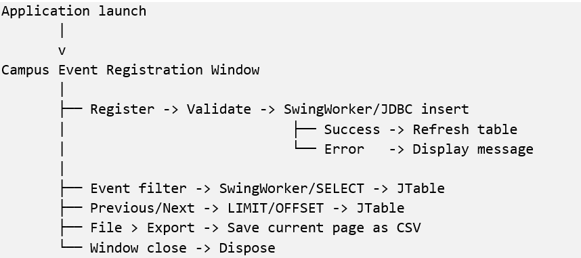

7.6 Pseudocode – Student Registration
PROCEDURE registerAction

Read student ID
Read student name
Read event name
Read email

Display "Registering..."

Execute SwingWorker

DO IN BACKGROUND

Validate input using RegistrationService

Insert registration using DAO
and PreparedStatement

Database UNIQUE constraint
prevents duplicate registration

ON COMPLETION

IF registration successful THEN

Display success message
Refresh registration table

ELSE

Display error message

END IF

END PROCEDURE

7.7 Pseudocode – Event Filtering
PROCEDURE filterAction

selectedEvent ← filterCombo selection

offset ← 0

Execute SwingWorker

DO IN BACKGROUND

rows ← DAO.page(
selectedEvent,
pageSize,
offset
)

ON COMPLETION

Clear JTable model

FOR EACH row IN rows

Add row to JTable

END FOR

Update status message

END PROCEDURE

7.8 Database Structure
The application uses a MySQL table named registrations.
CREATE TABLE registrations (

id INT AUTO_INCREMENT PRIMARY KEY,

student_id VARCHAR(20) NOT NULL,

student_name VARCHAR(100) NOT NULL,

event_name VARCHAR(100) NOT NULL,

email VARCHAR(150) NOT NULL,

created_at TIMESTAMP
DEFAULT CURRENT_TIMESTAMP,

CONSTRAINT uq_student_event
UNIQUE (student_id, event_name)

);
The UNIQUE constraint prevents duplicate registrations for the same student and event.

7.9 Test Cases
Test Case | Input | Expected Result
Valid Registration | Valid student details | Registration inserted successfully.
Duplicate Registration | Same student ID and event | Duplicate registration rejected.
Invalid Student ID | Empty or invalid ID | Validation error displayed.
Invalid Name | Empty or one-character name | Validation error displayed.
Invalid Email | Incorrect email format | Validation error displayed.
Event Filtering | Select a particular event | Matching registrations displayed.
CSV Export | Select Export Current Page | Current page exported to CSV.

7.10 Pagination and Database Retrieval Comparison
The application uses pagination to retrieve registration records instead of loading all records into the GUI at once.
Parameter | Loading All Records | Pagination
Records Retrieved | All 100,000 records | Limited records per page
Data Transfer | High | Lower per request
GUI Memory | O(N) | O(p)
Responsiveness | Large data loads can cause delays | Background loading maintains GUI responsiveness
Navigation | All records available together | Previous and Next controls retrieve different pages
Here:
- N = Total number of records.
- p = Number of records per page.
For 100,000 registrations and a page size of 25, pagination displays approximately 25 records at a time.
The use of SwingWorker ensures that database operations are performed in the background rather than blocking the Swing event-dispatch thread.

8. OVERALL CONCLUSION
This assignment demonstrates the implementation of event-driven Java applications using AWT and Swing.
Task 1 demonstrates the separation of GUI components and payment-processing logic.
Task 2 implements event handling for a hospital appointment desk, including department-based doctor selection and appointment booking.
Task 3 demonstrates the use of nested layout managers to develop a responsive campus library search interface.
Task 4 identifies and corrects mouse-event handling errors and implements persistent drawing using an ArrayList and repainting.
Task 5 implements four different event-handling techniques in a currency converter and compares their characteristics.
Task 6 develops a campus event registration application using Java Swing and JDBC, including input validation, database operations, duplicate prevention, event filtering and pagination.
Through these implementations, the assignment demonstrates the practical application of Java event handling, GUI design, object-oriented programming and database connectivity.

9. REFERENCES
- Programming in Java (CSA09), Assignment 4 – CO4: Event-Driven GUI Design.
- Java AWT and Swing class documentation.
- Java Event Handling and Listener Interfaces.
- Java JDBC documentation.
- MySQL Database Documentation.

